**The Tableau HR Scorecard:Measuring Success in Talent Management**

1. Introduction :
   1. Overview :

[Talent management is a strategic process that involves attracting, motivating, developing, and retaining high-performing employees](https://www.bing.com/ck/a?!&&p=c2ca0a866bdfc736JmltdHM9MTY5NjQ2NDAwMCZpZ3VpZD0zNjRhYjhkMS1iZmQ1LTYyYzMtMmJkNC1hYWQ3YmU3ODYzODcmaW5zaWQ9NTgyOQ&ptn=3&hsh=3&fclid=364ab8d1-bfd5-62c3-2bd4-aad7be786387&psq=talent+management+overview&u=a1aHR0cHM6Ly93d3cuaW5kZWVkLmNvbS9jYXJlZXItYWR2aWNlL2NhcmVlci1kZXZlbG9wbWVudC93aGF0LWlzLXRhbGVudC1tYW5hZ2VtZW50&ntb=1" \t "https://www.bing.com/_blank) First.I have done my EMPATHY MAP.I created flow chart about my topic.How to improve our business in the talent management will be say in flow chart.Next I created BRAINSTROME .Our team take problem statement and we discuss how to solve the problem our team problem statement in measuring success in talent management .Then I created my data analysis- Dashboard and Story.Next I publish my Dashboard and story in tableau public.

* 1. Purpose:

Data analysis is the process of working with data to extract useful information that can be used to make informed decisions. It is a practice that has become increasingly important in recent years, as companies have more data than ever at their disposal. [Data analysis can help businesses personalize customer interactions, predict future health needs, or create the next big streaming hit](https://www.coursera.org/articles/what-is-data-analysis-with-examples" \t "https://www.bing.com/_blank).

1. Problem Definition & Design Thinking:
   1. Empathy Map:

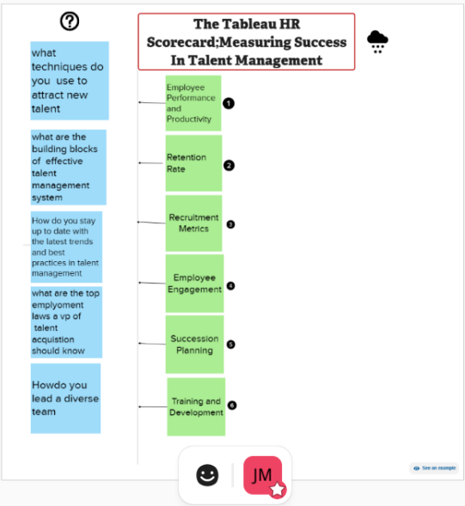

2.2 Ideation & Brainstorming Map:

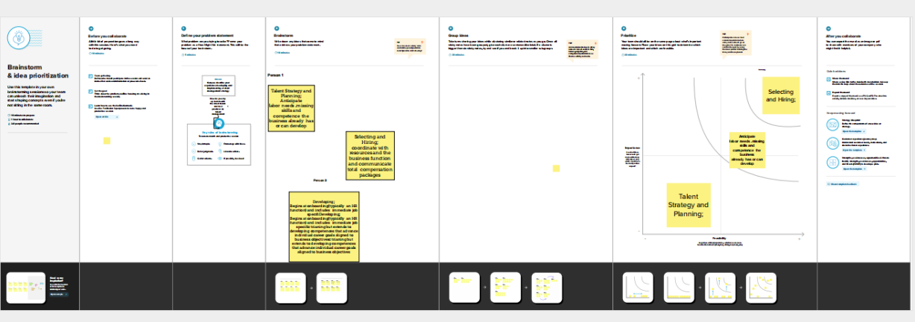

3.Result :

HR Analytics Dashboard:

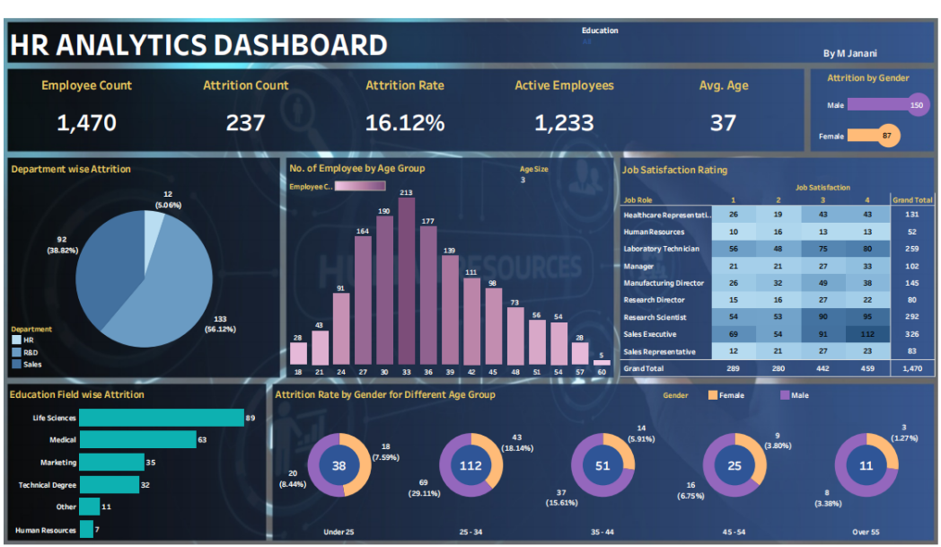

HR Analytics Storyline:

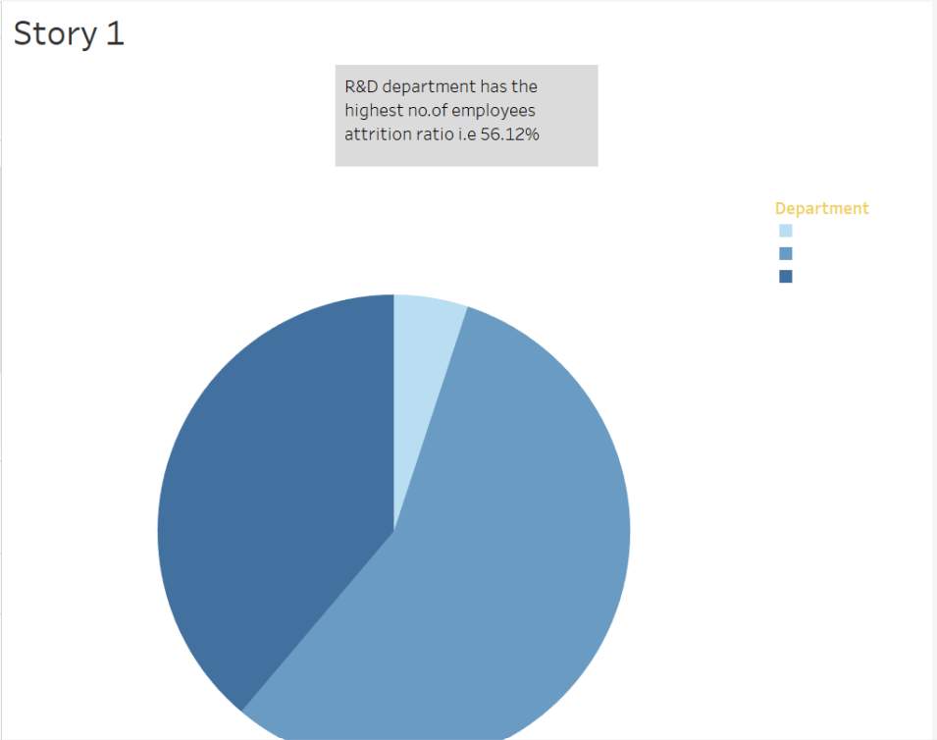

No of employees by age group

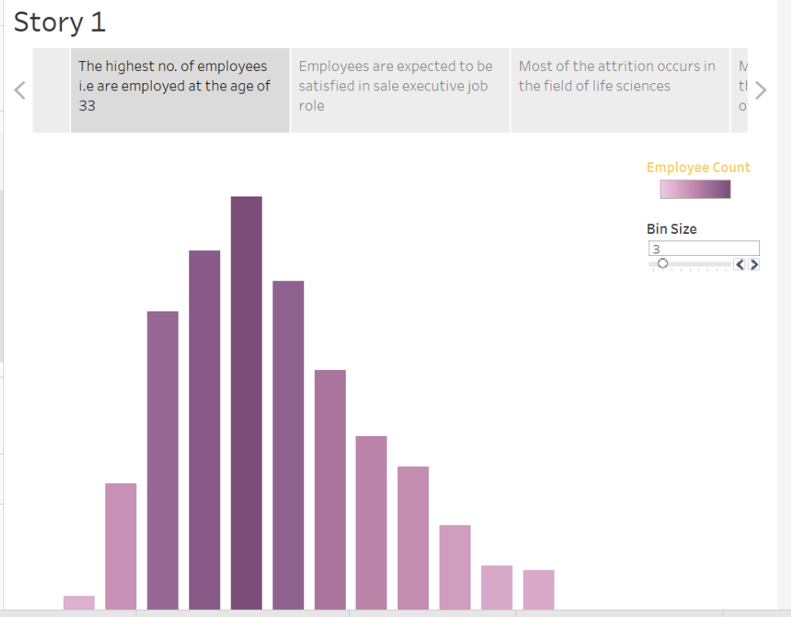

Job Satisfaction Rating:

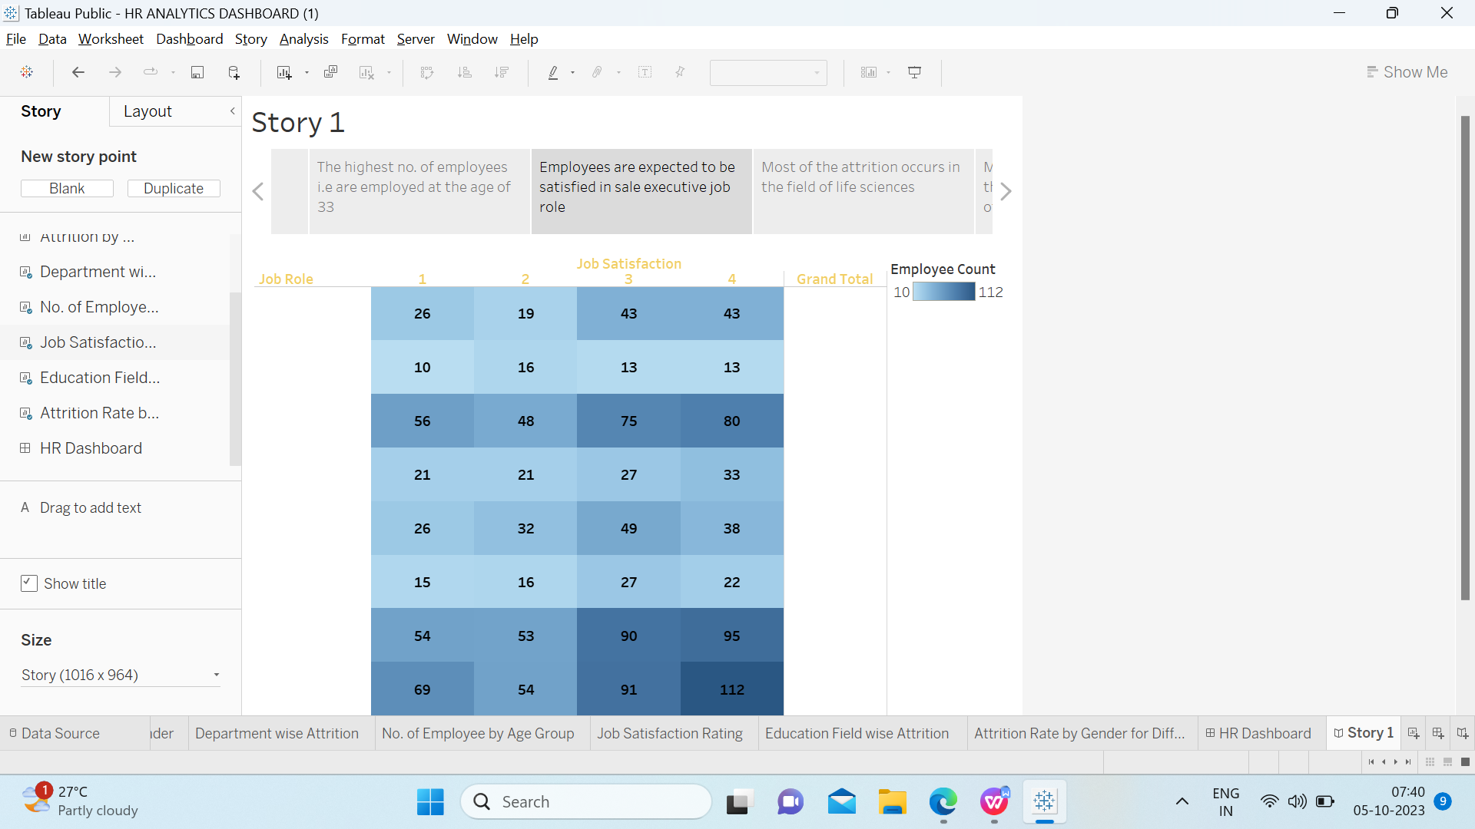

Education Field Wise Attrition:

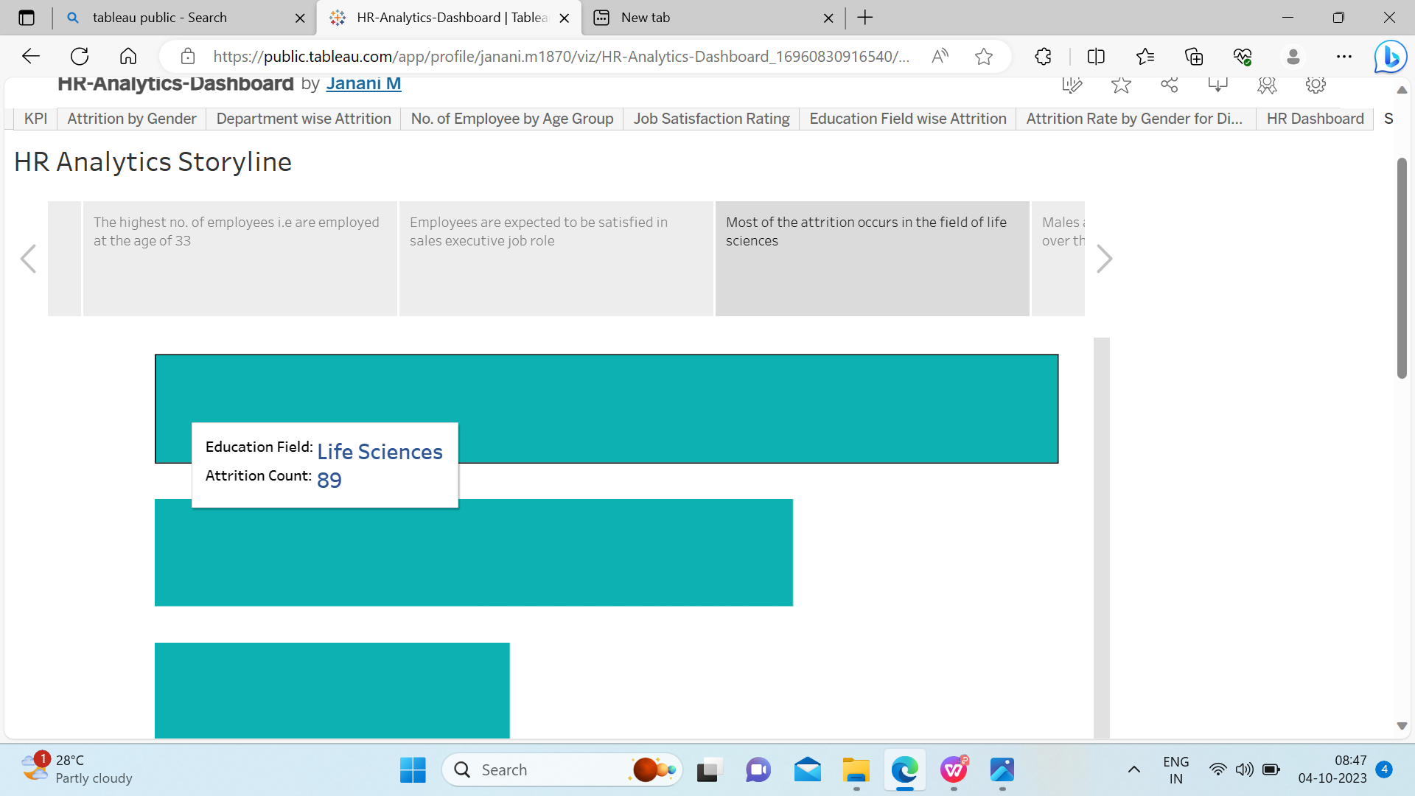

Attrition Rate by Gender for different age groups:

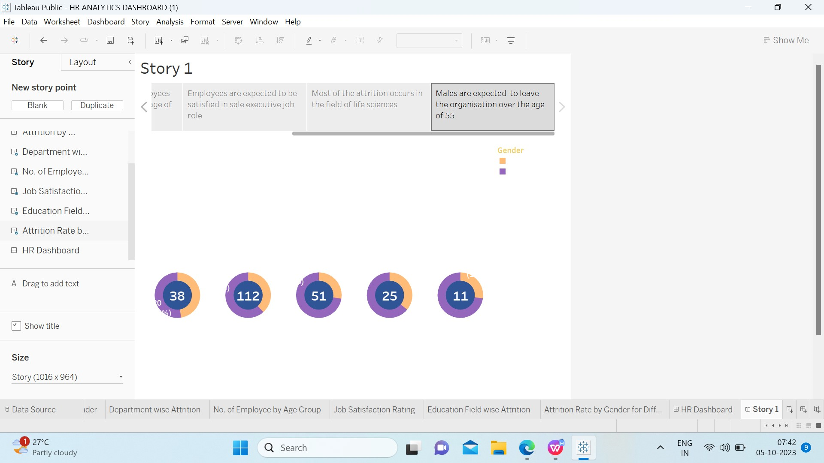

4.Advantages & Disadvantages:

Advantages:

* Track employees seamlessly from hire to retire.
* Identify skills gaps and development opportunities.
* Connect performance to compensation management and career growth.
* Develop robust succession plans based on accurate data.
* Better employee retention
* Increased performance

Disadvantages:

* The implementation of talent management program could be expensive in terms of time,resources and financial costs.
* Lack of support from line managers can impede the level of commitment from employees.
* There are people who underestimate your talent.

1. Application:

* Talent management software provides many advantages in the area of recruitment,performance management,training and education, and compensation management.
* Companies can collect,centralize,track,store,report and analyze employee data,while receiving automated remainders and notifications.
* The talent management we apply to business in some difficult situation.
* KPIS could include metrics such as employee turnover rates, time -to-fill positions, training completion rates, and employee satisfaction scores.

1. Conclusion:

Talent management in an organization aims at ensuring employee recruitment,training and development,performance reviews and their compensation.Working towards enhancing a good talent management system in the organization ensures these components of human resource contribute to the success of the organization.The advantages that the components bring to the organization also outweigh the disadvantages considering organizations benefit from these approaches.These ensure the organization attracts highly qualified employees and find it easy to retain them and hence improving their human resource element.Talent management enhances reviews that prove vital in developing employees.Therefore,the application of talent management proves an ideal approach in employee development and improving the performance of each personnel.

1. Future Scope:

In the recent days,the HR department of any organization is vested with the responsibility of managing the talent in addition to its conventional function of providing good human capital to an organization.In order to perform this function,they use the following methods viz…,

* Identifying the talent which is required
* Right selection of the talent
* Implementation competitive compensation plans
* Aligning the acquired talent
* Retaing the talent

The scope of talent management is quite wide and adopts an integrative approach to the function mentioned above.